Post-Doctoral Position available on biology and innovative therapy of Autosomal Recessive Osteopetrosis

The “Unit of Pathogenesis and Treatment of Immune and Bone Diseases” lab, led by Anna Villa at the San Raffaele Telethon Institute for Gene Therapy (SR-TIGET), Milan, Italy is recruiting a highly motivated post-doctoral fellow with strong experience in hematopoietic stem cell biology and bone marrow niche. The project will be focused on the study of ectopic bone marrow niche and optimization of innovative gene correction platform
The research activities of our laboratory are focused on the study of pathological mechanisms of immune and bone diseases and the preclinical evaluation of innovative therapeutic approaches based on gene therapy, gene editing and novel conditioning regimens. As part of the SR-TIGET, a world-leading Institute in the field of gene and cell therapy for the treatment of human genetic diseases, we benefit from a highly competitive, international and scientifically stimulating environment and offer excellent state-of-the-art facilities and infrastructures, and access to clinically relevant human samples.
The candidate must hold a PhD Degree Biological Sciences, Immunology, Biotechnology or related disciplines and have previous research experience in molecular and cellular biology, flow cytometry, animal handling, as well as primary human cell culture and manipulation. Experience in single cell transcriptomic is appreciated Proficient English, independent working capacity, proactive attitude mindset, excellent organizational skills and team spirit are required.
The successful candidate will be offered a 1 -year renewable contract with extension thereafter and a salary negotiated depending on experience.
Interested candidates should submit their application with a detailed CV, a cover letter, and names of 2 references to Anna Villa (villa.anna@hsr.it)

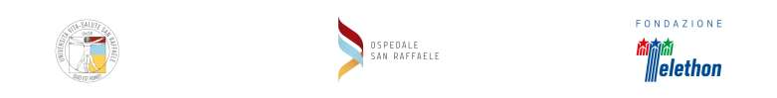
Via Olgettina, 60 20132 Milano, Italia - Tel. 02 26 431 - info@hsr.it

